# Genetic Algorithm Report:

The 4 lines in each graph represent each iteration of Genetic Algorithm for statistical Significance.

Population size vs number of generations:

Range of Population size: 4 – 12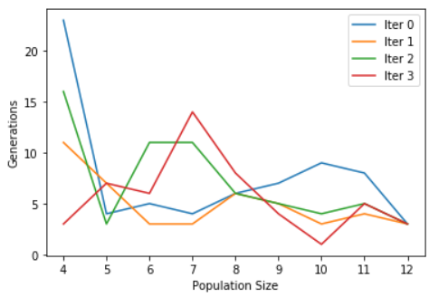

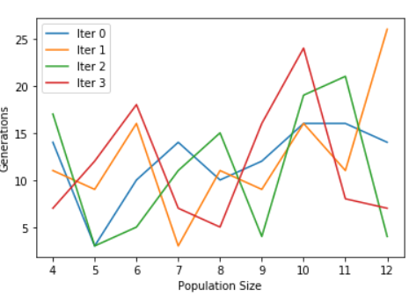

Chromosome Length: 8

Chromosome Length: 12

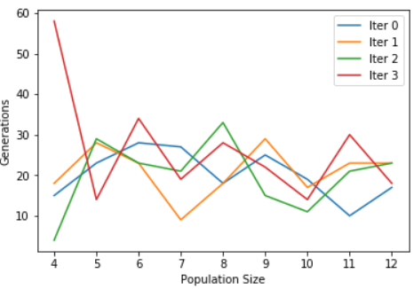Chromosome Length: 16

Inference:

Number of Generations to solution Decreases slightly as Population Sizes increase.

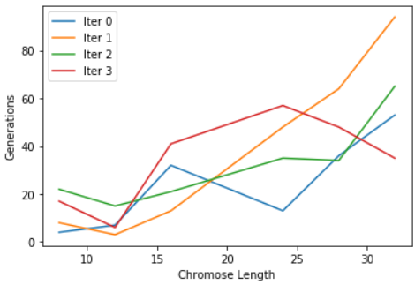Part 3: Chromosome Length vs number of generations:

Population size: 4

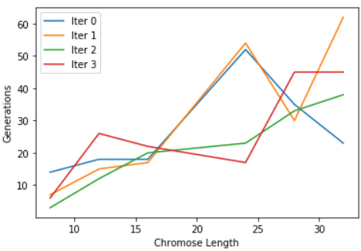

Population size: 6

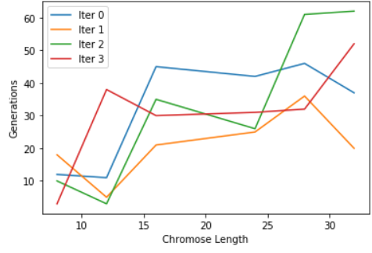Population size: 8

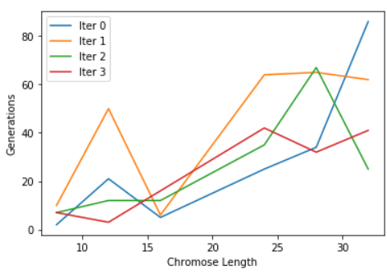

Population size: 10

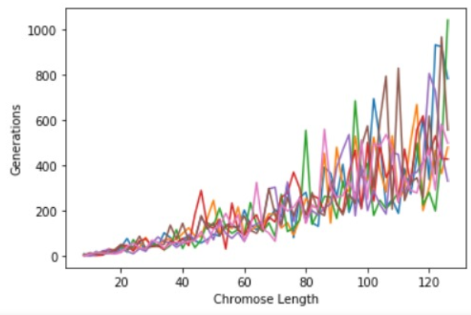

All lines are different values of Population sizes Ranging from 4 – 100.

Inference: Number of Generations to solution increase as Chromosome Length increase.